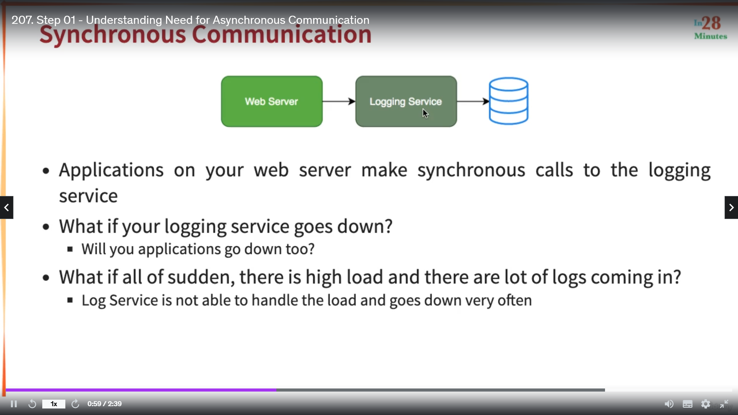

Your application is talking with Logging Service which is storing logging data.

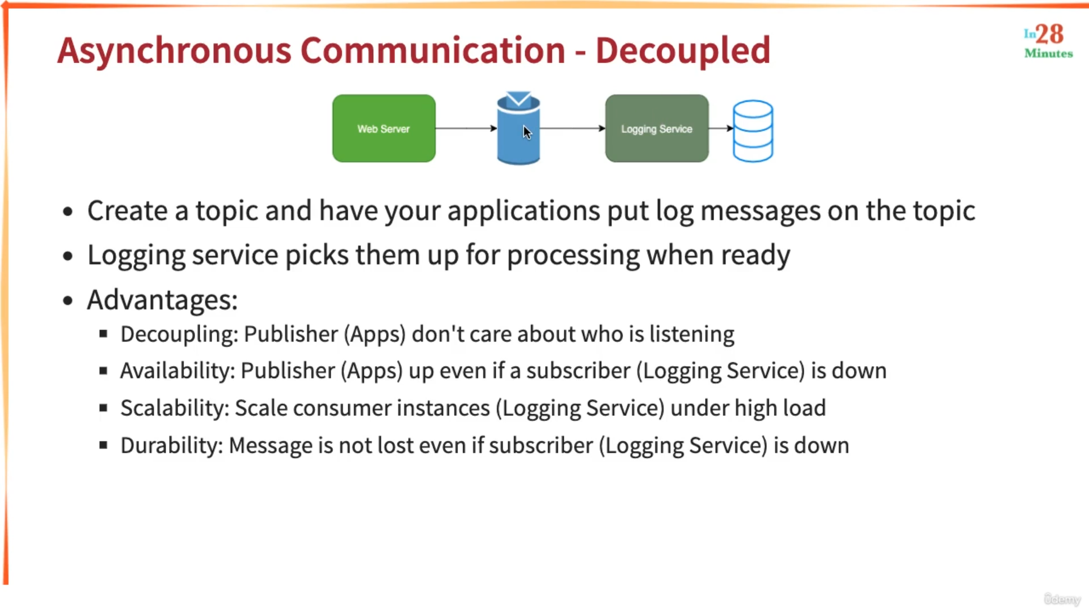

Scalability : We can increase the number of instances of Logging Service if there is a lot of message in the topic.

Availability: Even if Logging service is down messages are still there in topic. Logging service can start picking up the messages whenever it is ready.

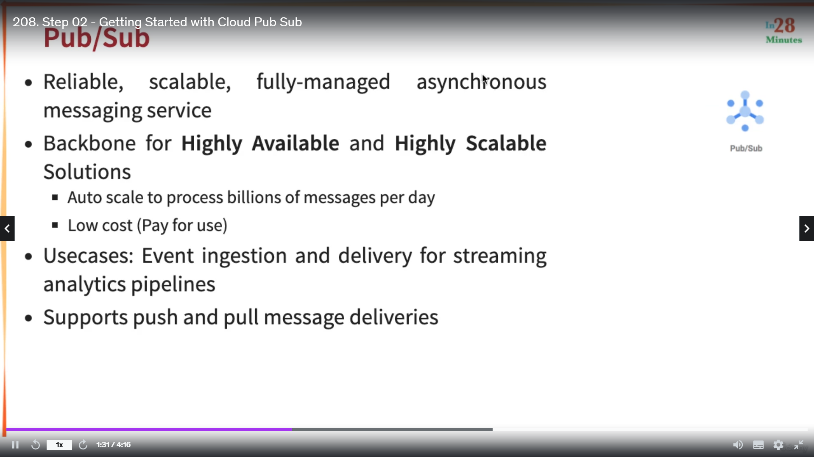

Subscribers Receive the message in two ways. Pull and Push.

Pull : here subscribers pull the message from topic whenever required.

Push: whenever there is a message in the topic it sends to all the subscribers.

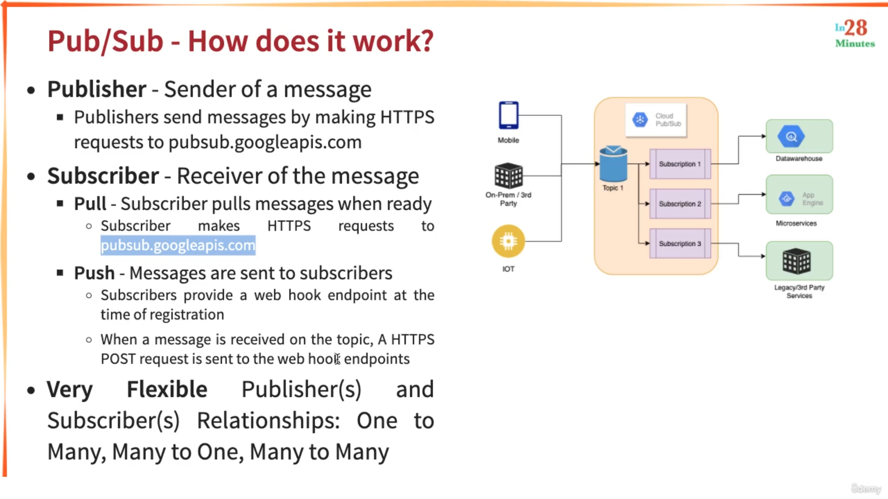

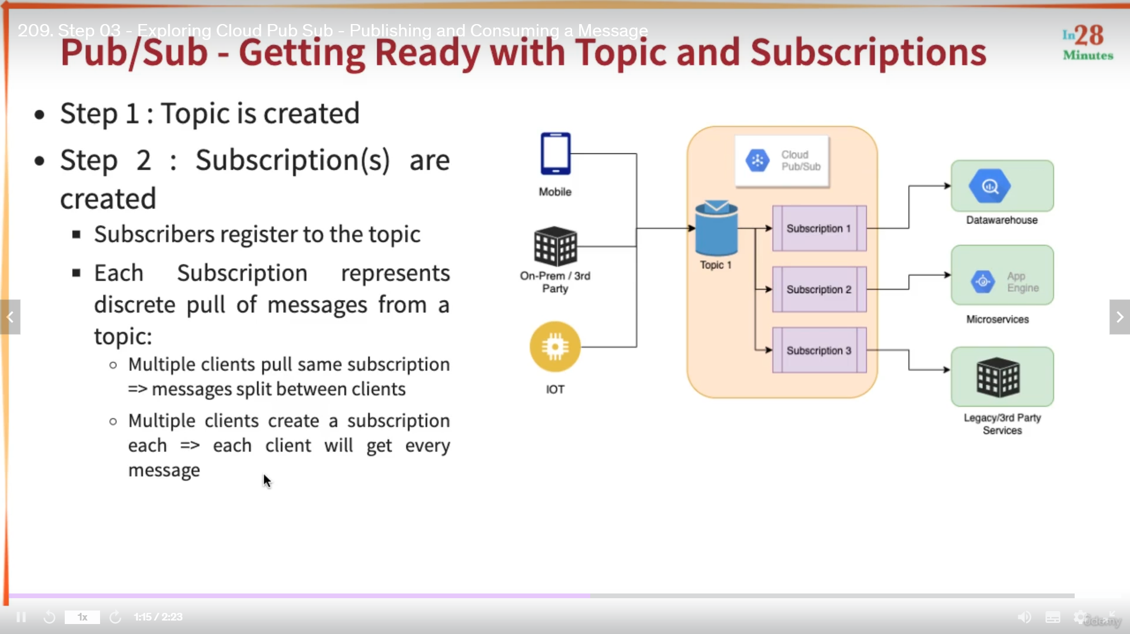

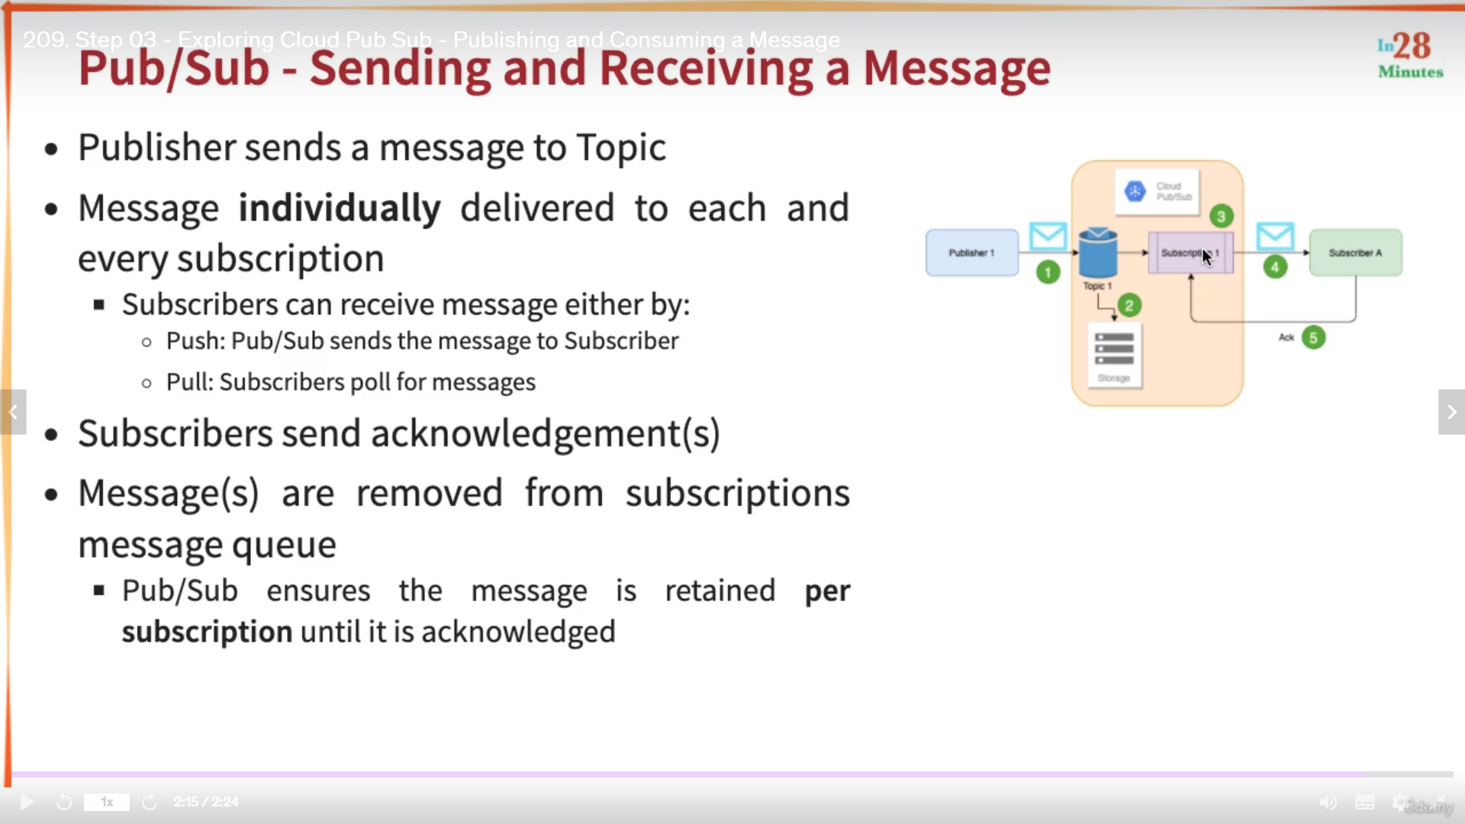

Hands on

Click Pub Sub

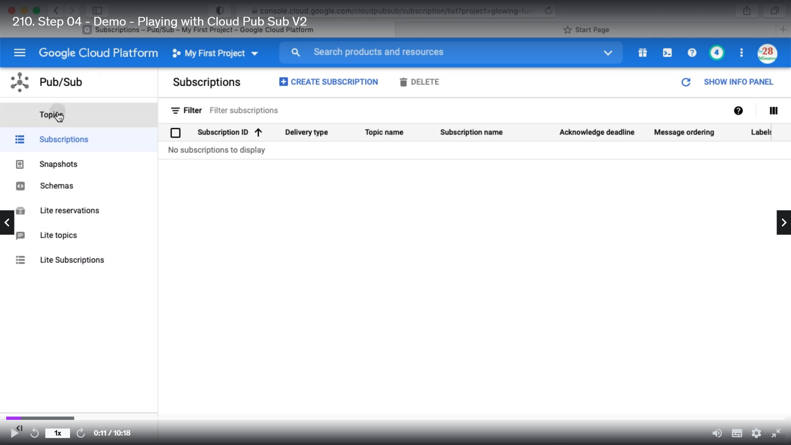

Click create topic

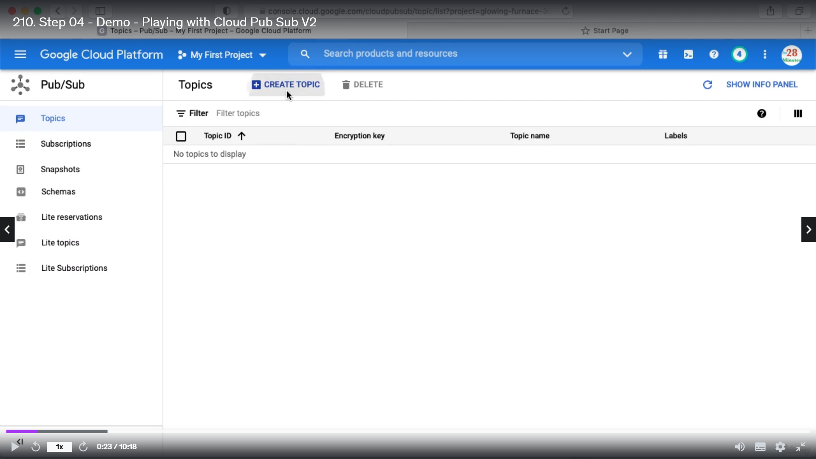

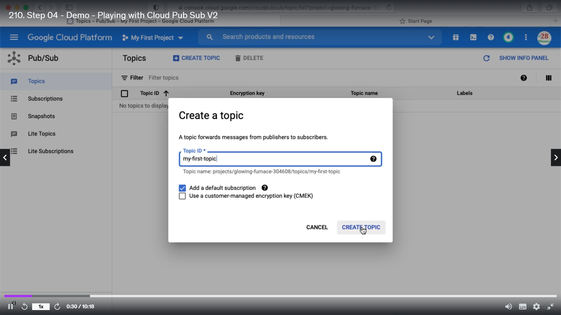

This will also create a default subscription.

Now we will create another subscription apart from the existing one.

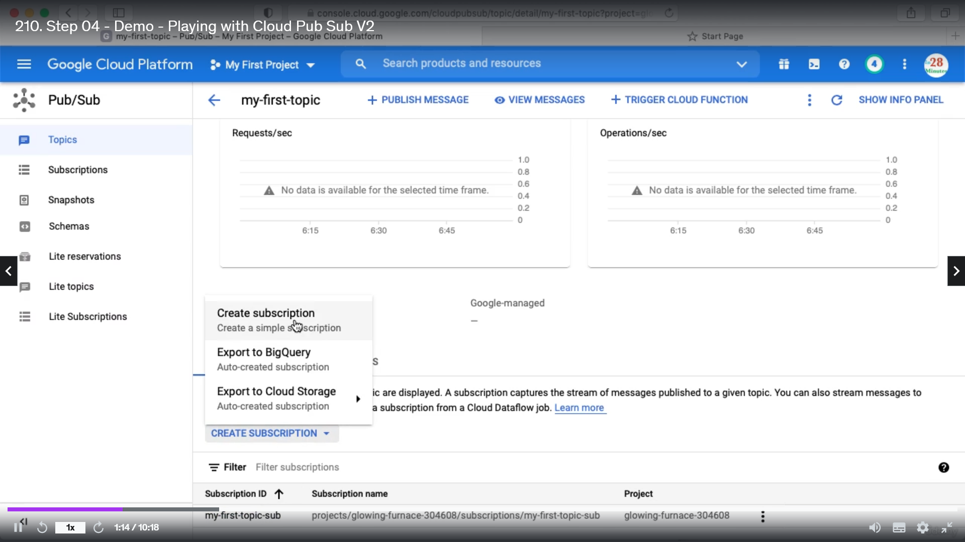

Give details and click create.

I want publish a message to topic. Go to topic -> go to messages

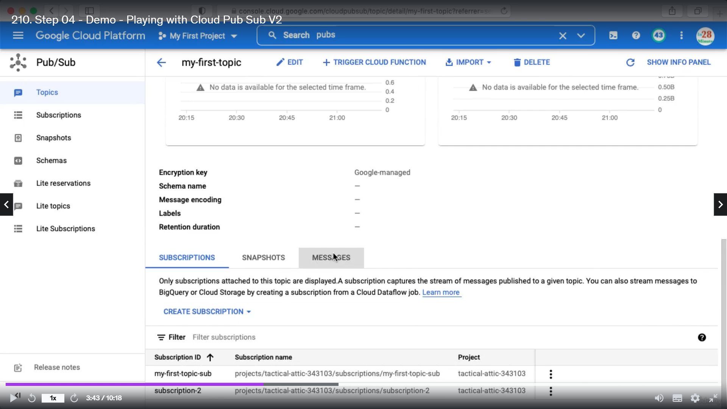

Click publish message

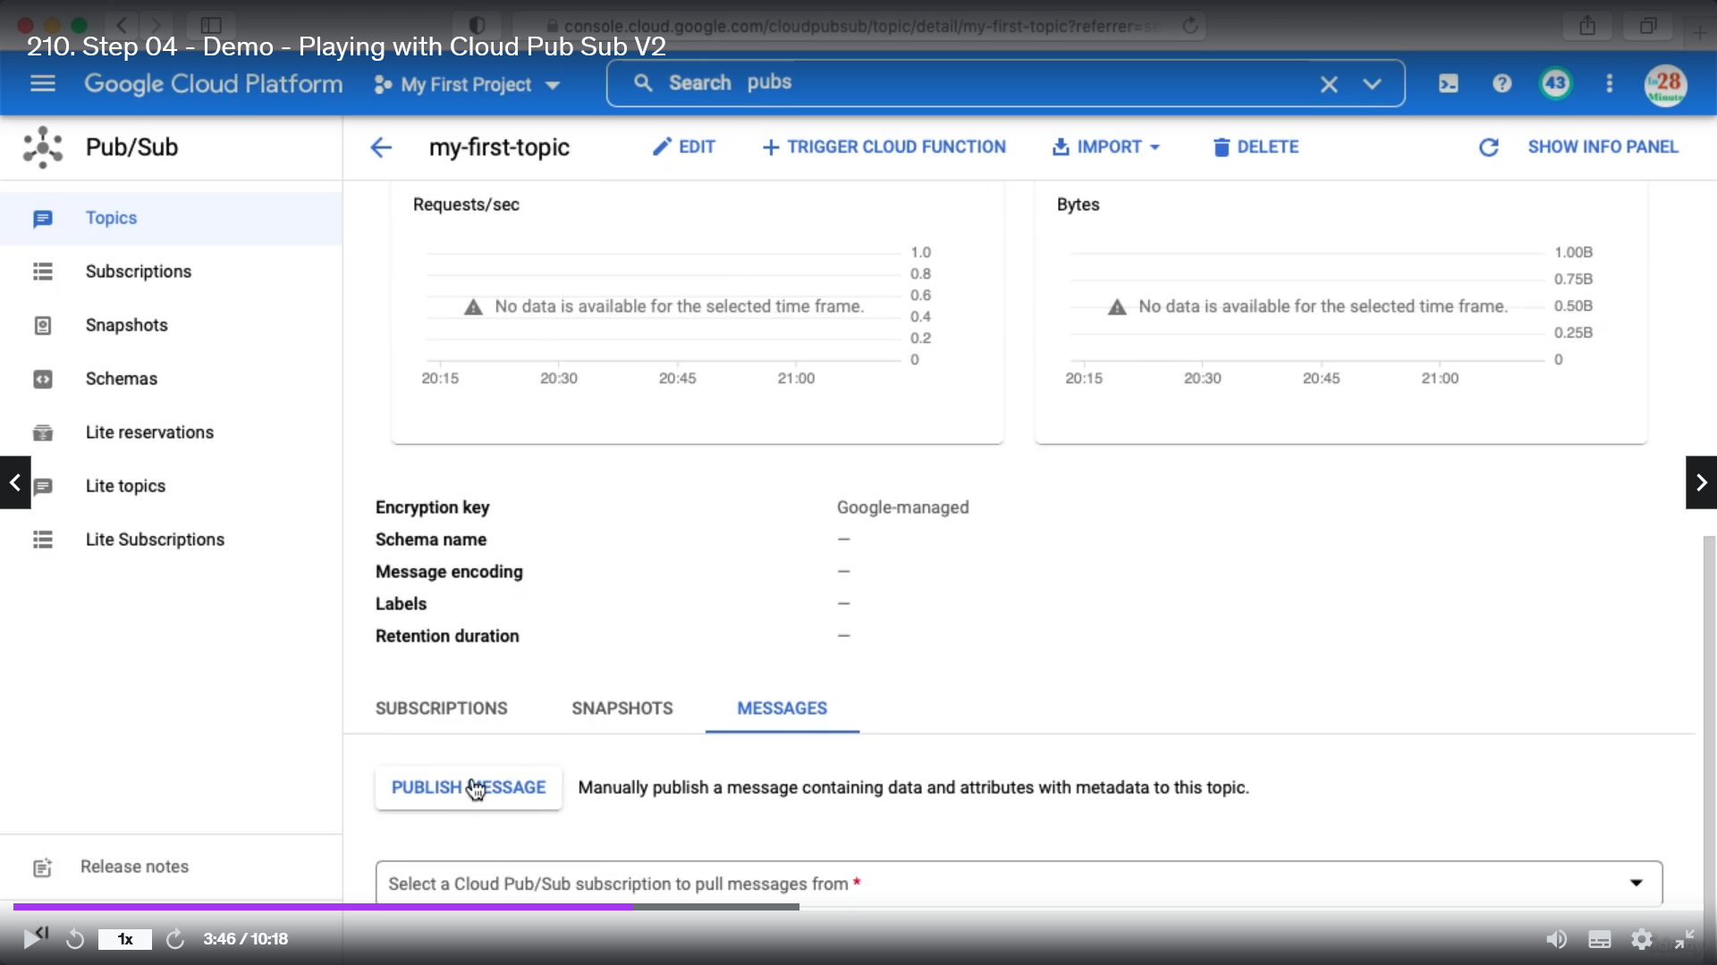

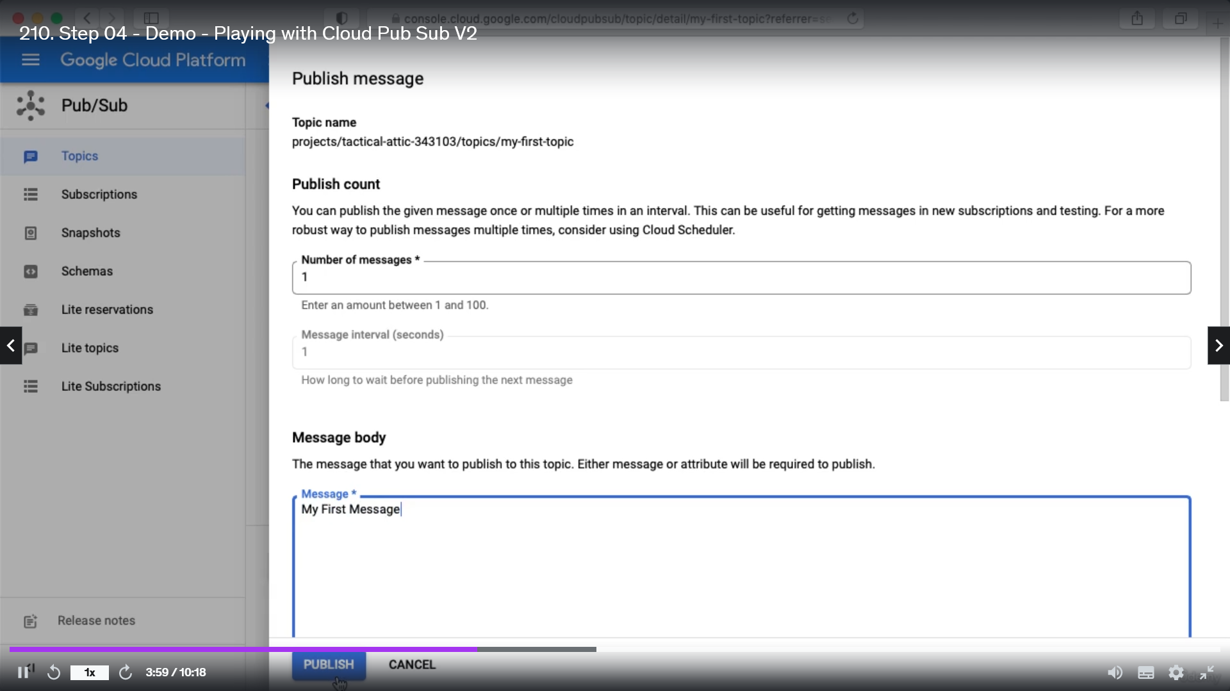

If you go to subscription tab you can see all the subscriptions for that topic

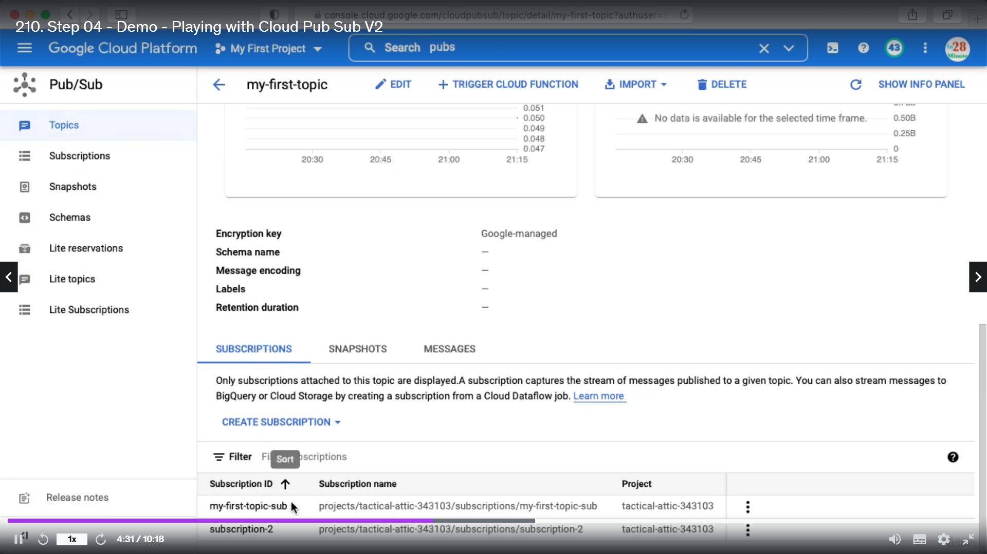

Go to each subscription and click pull

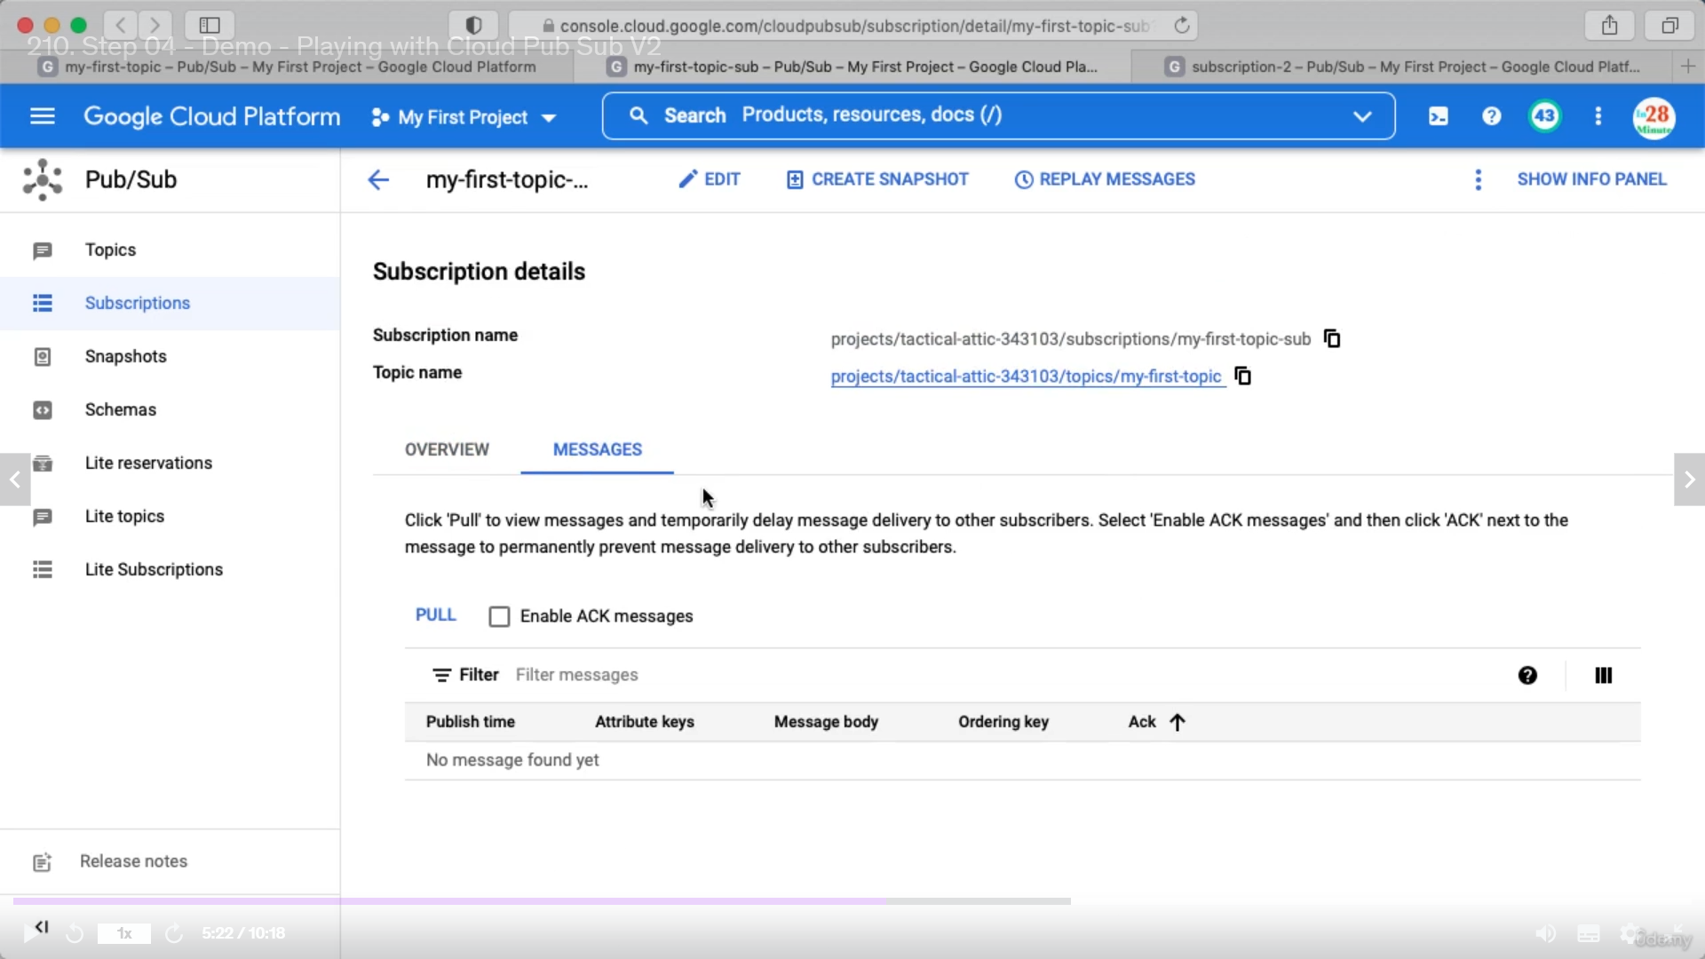

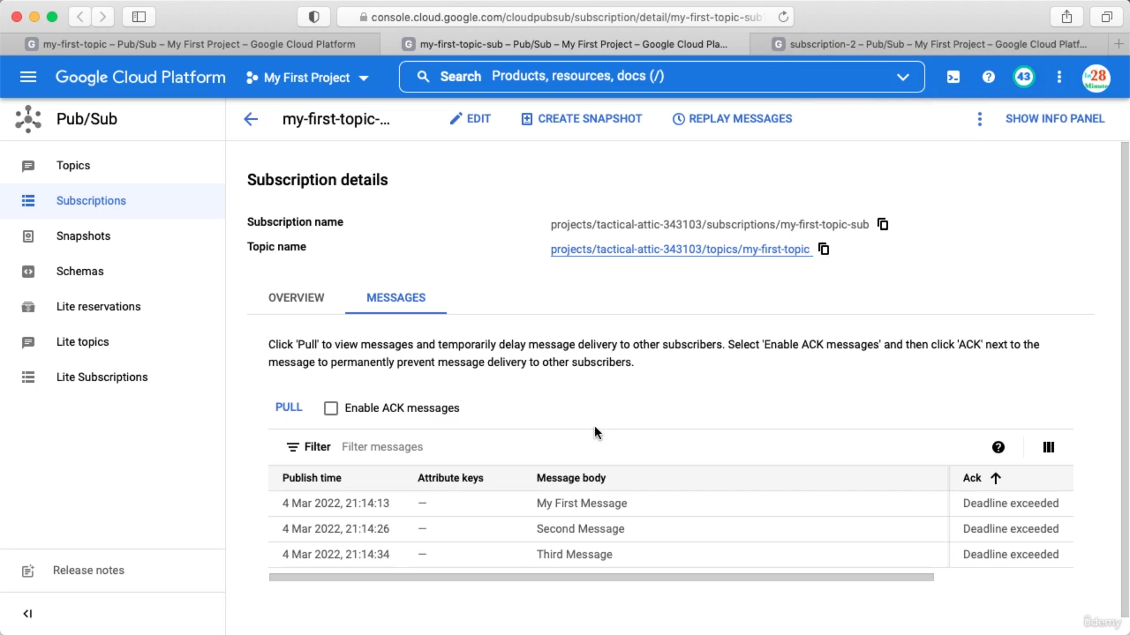

Before exceeding we need to send acknowledgement. In the above it is showing Deadline exceeded. So the acknowledgement is not sent yet. Now if we click pull again we will be able to get the messages because they are still present in the topic.

We can check enable acknowledgement check box

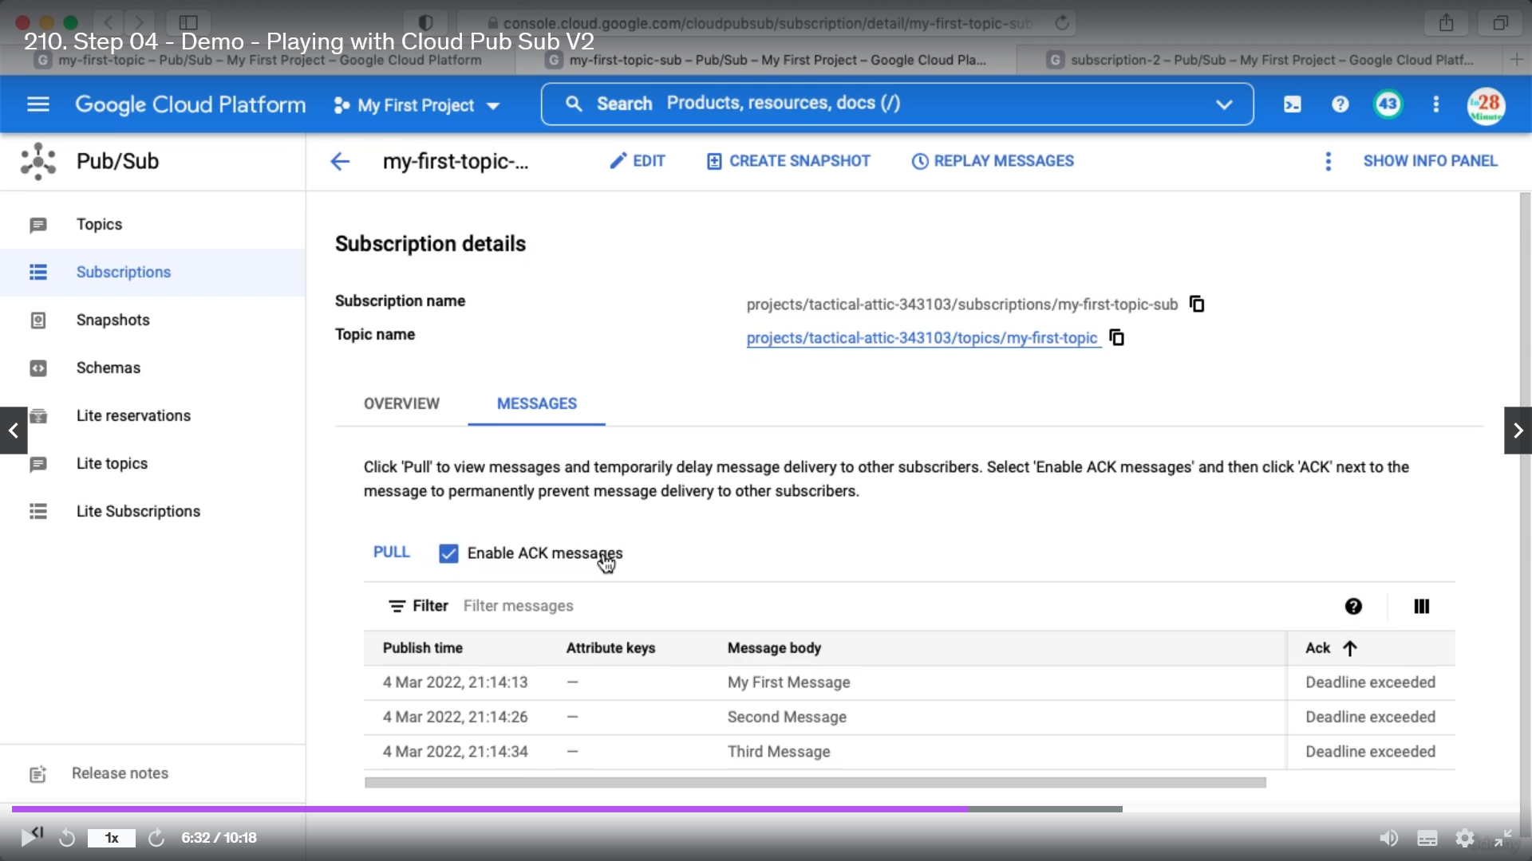

Unless all the messages for all the subscriptions are acknowledged the message will remain in the topic.

We can also create a snapshot. This will tell us what is the state of subscription.

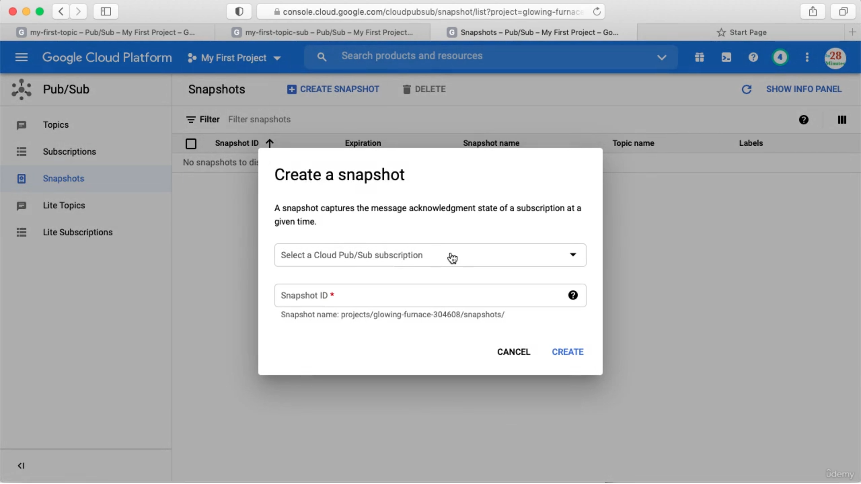

There is also pub sub lite is available. The only difference is the data is replicable in zonal so it is cheaper.

Commands

1. gcloud config set project glowing-furnace-304608
2. gcloud pubsub topics create topic-from-gcloud
3. gcloud pubsub subscriptions create subscription-gcloud-1 --topic=topic-from-gcloud
4. gcloud pubsub subscriptions create subscription-gcloud-2 --topic=topic-from-gcloud
5. gcloud pubsub subscriptions pull subscription-gcloud-2
6. gcloud pubsub subscriptions pull subscription-gcloud-1
7. gcloud pubsub topics publish topic-from-gcloud --message="My First Message"
8. gcloud pubsub topics publish topic-from-gcloud --message="My Second Message"
9. gcloud pubsub topics publish topic-from-gcloud --message="My Third Message"
10. gcloud pubsub subscriptions pull subscription-gcloud-1 --auto-ack
11. gcloud pubsub subscriptions pull subscription-gcloud-2 --auto-ack
12. gcloud pubsub topics list
13. gcloud pubsub topics delete topic-from-gcloud
14. gcloud pubsub topics list-subscriptions my-first-topic

While creating a subscription we can add below options

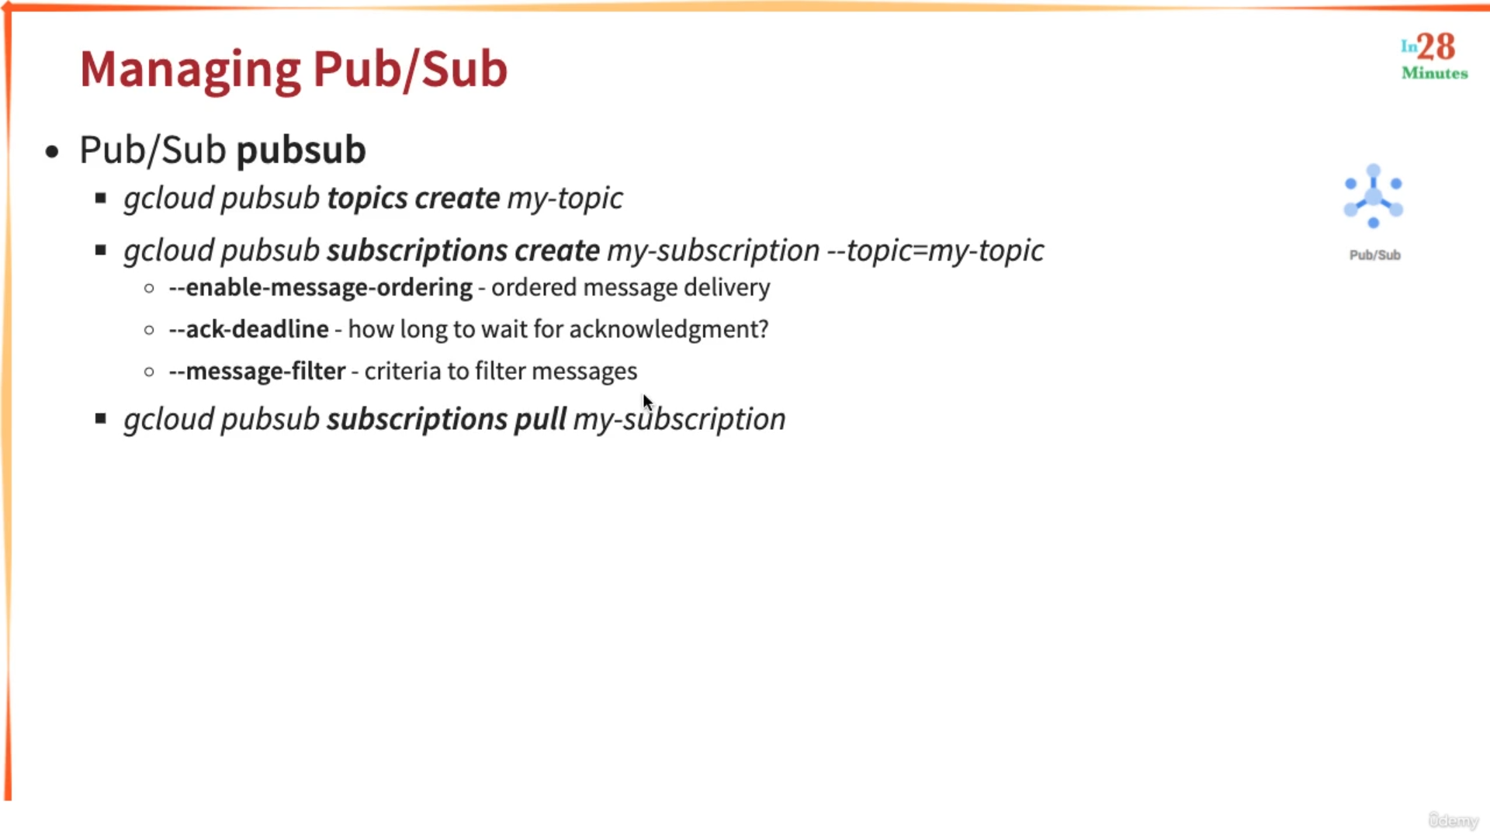

--message-filter:All the subscriptions might not interest in all the messages. We can add filter so that based on the criteria subscription will pick a specific message.

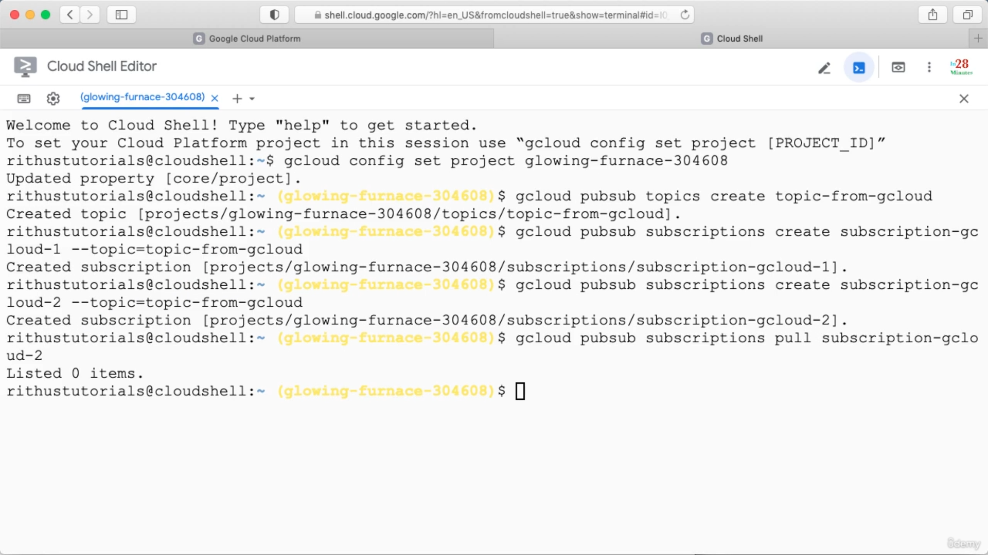

Publishing message into topic

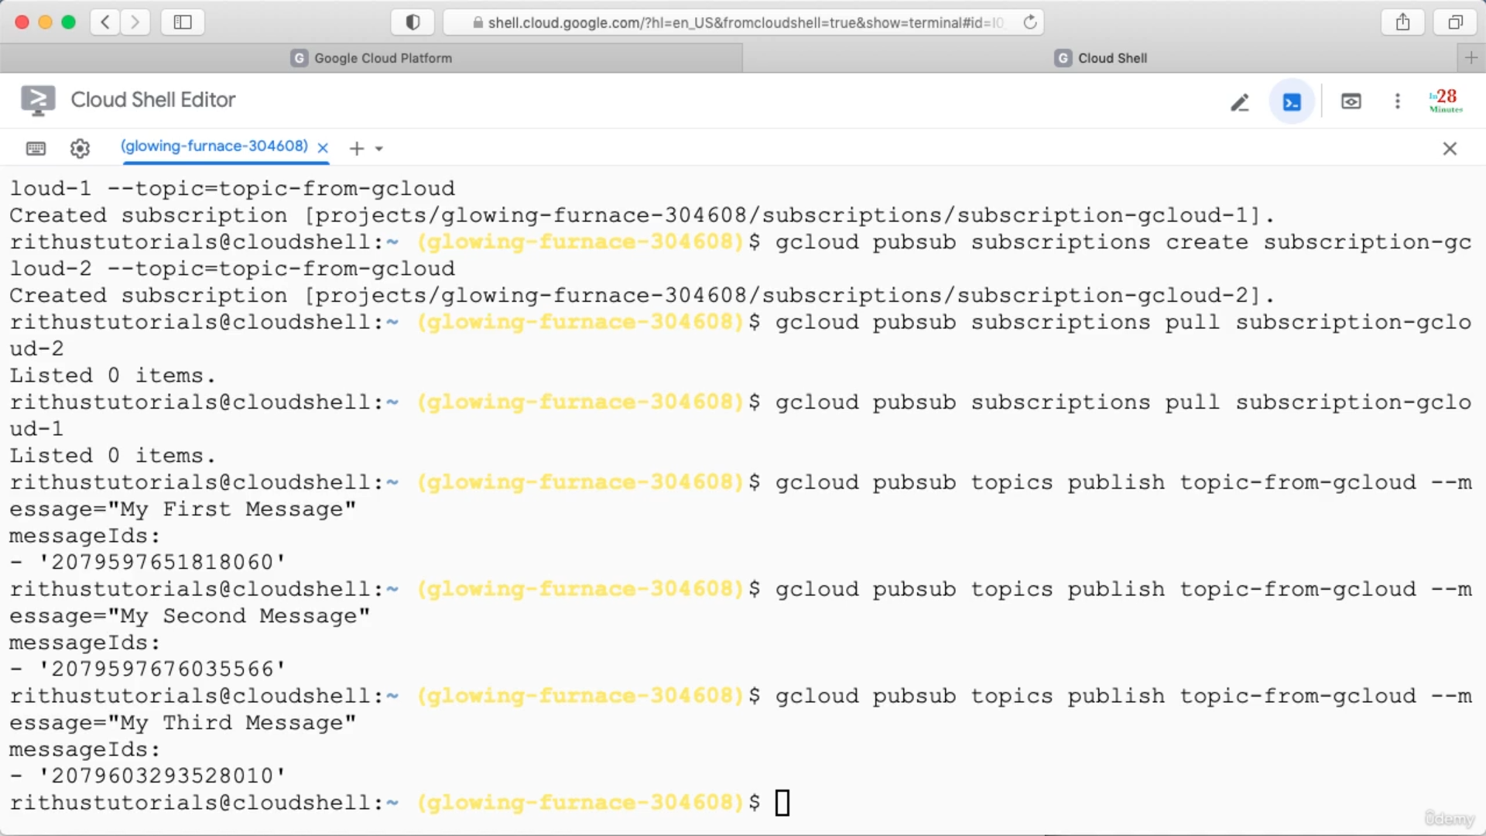

If we pull the message from a subscriber we will also get a acknowledgement id.

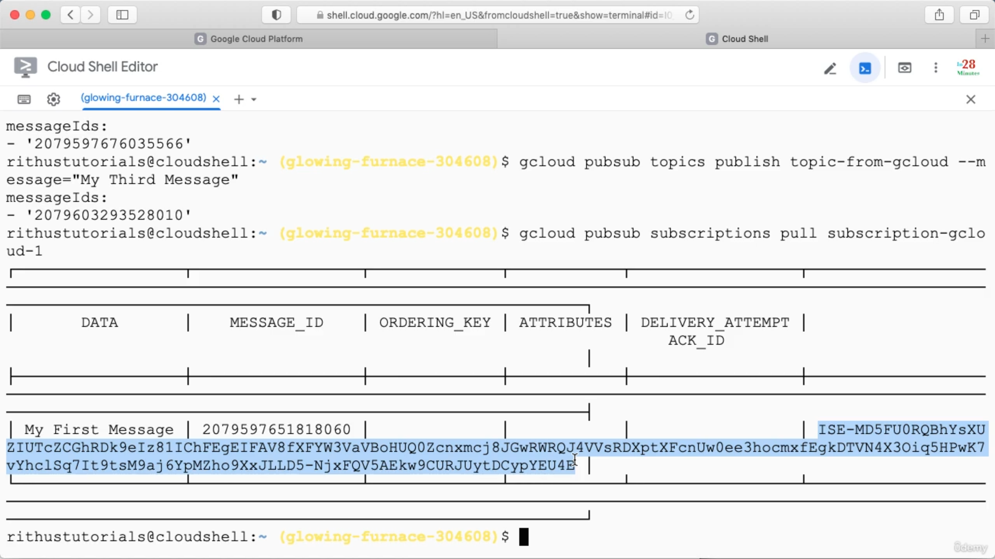

Acknowledgement should happen before deadline. The default deadline is 10 seconds.

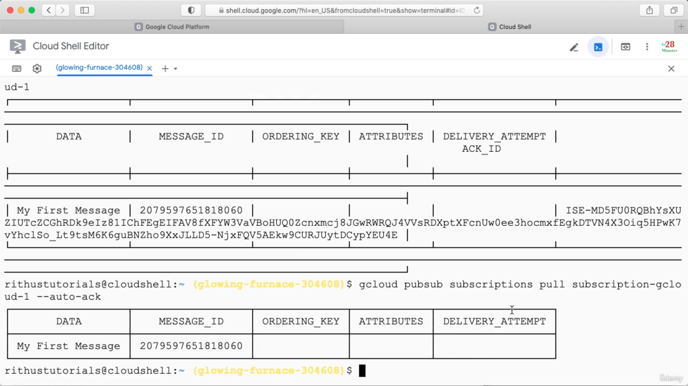

--auto-ack : will send the acknowledgement immediately.

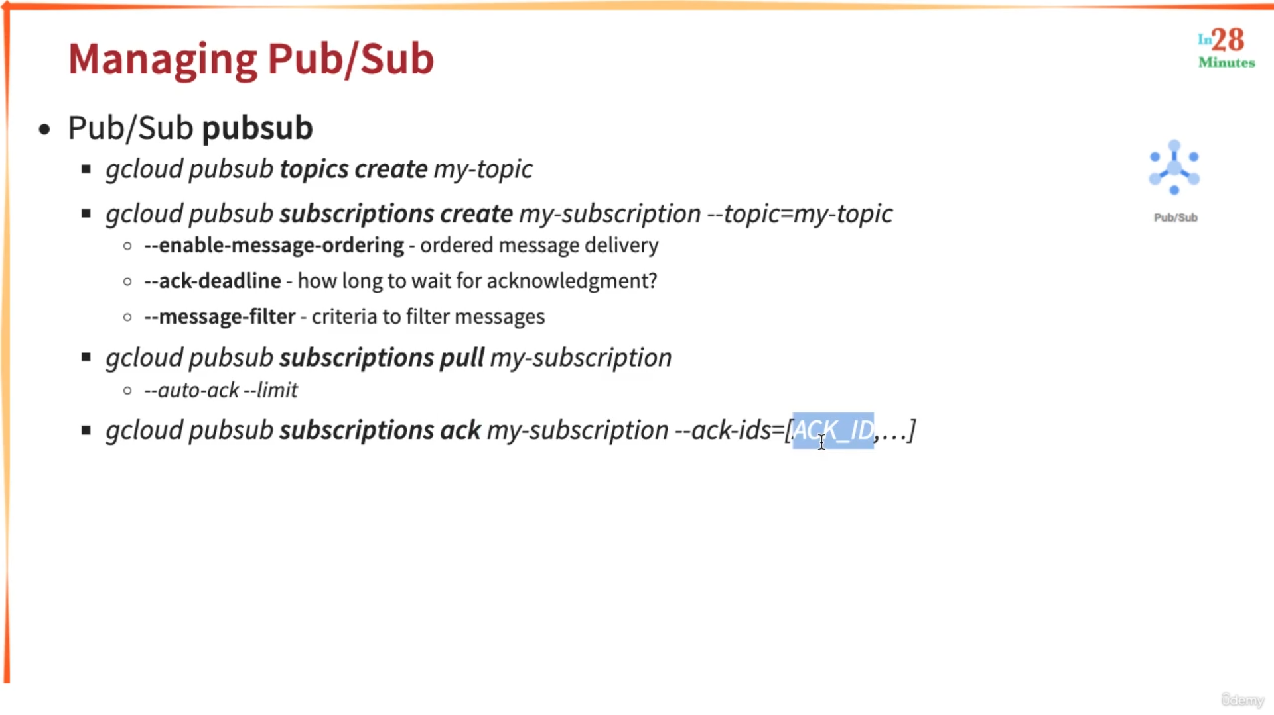

--limit: how many message we want to see. (Need to check via hands on)

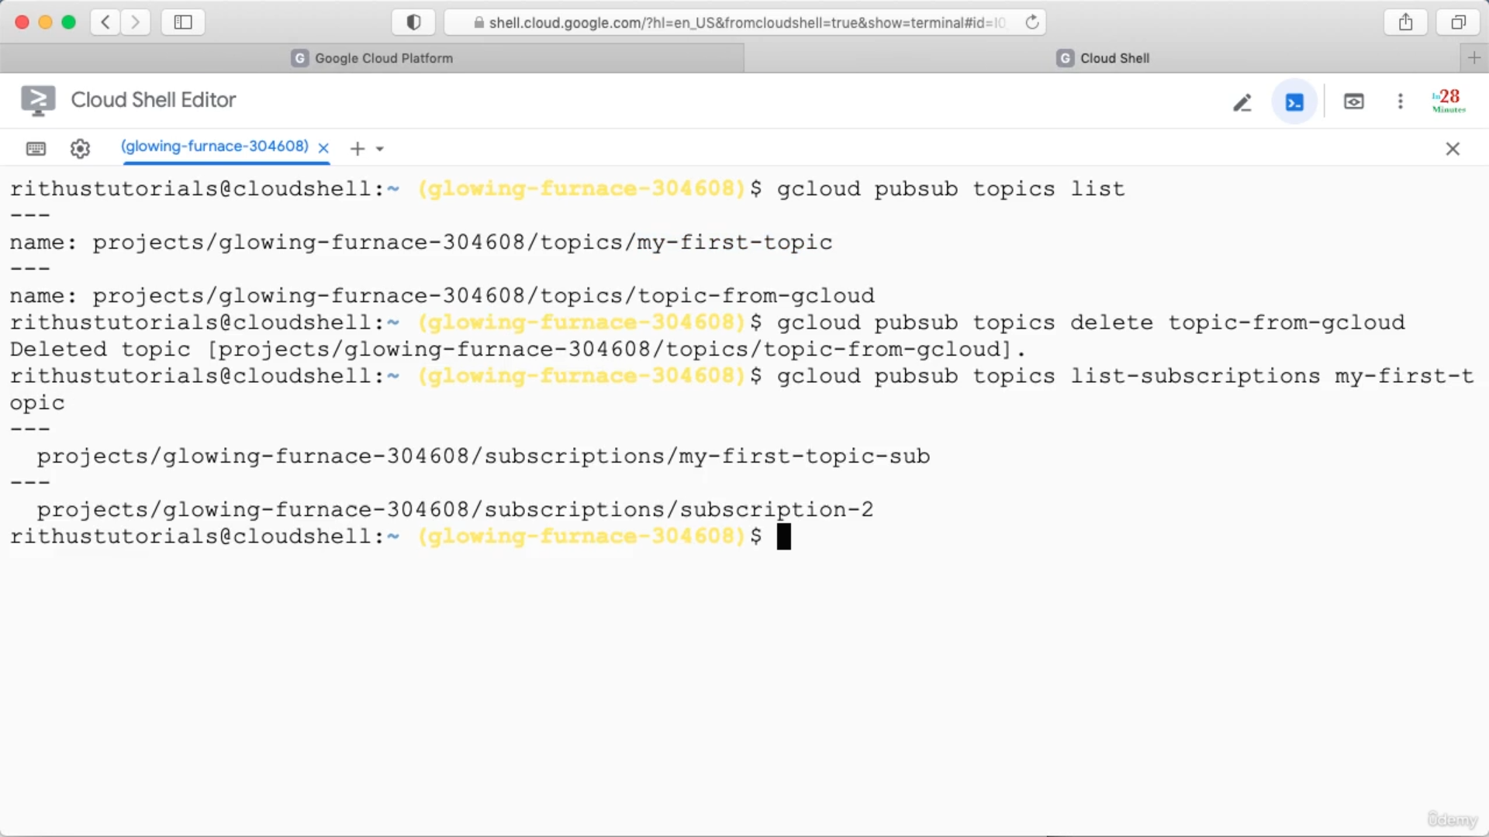

Summary

